Individual Task-4
“Create an ANN Flowchart: Manually sketch a feedforward neural network, label layers, activations, explain how backpropagation adjusts weights.”
Introduction:
Overview of Artificial Neural Networks (ANNs):
Artificial Neural Networks (ANNs) are computing systems inspired by the human brain. They consist of interconnected nodes called neurons, which work together to process information. ANNs can learn patterns from data, make predictions, and solve complex problems that are difficult for traditional programming. Each neuron receives inputs, processes them using a function called the activation function, and passes the output to the next layer.
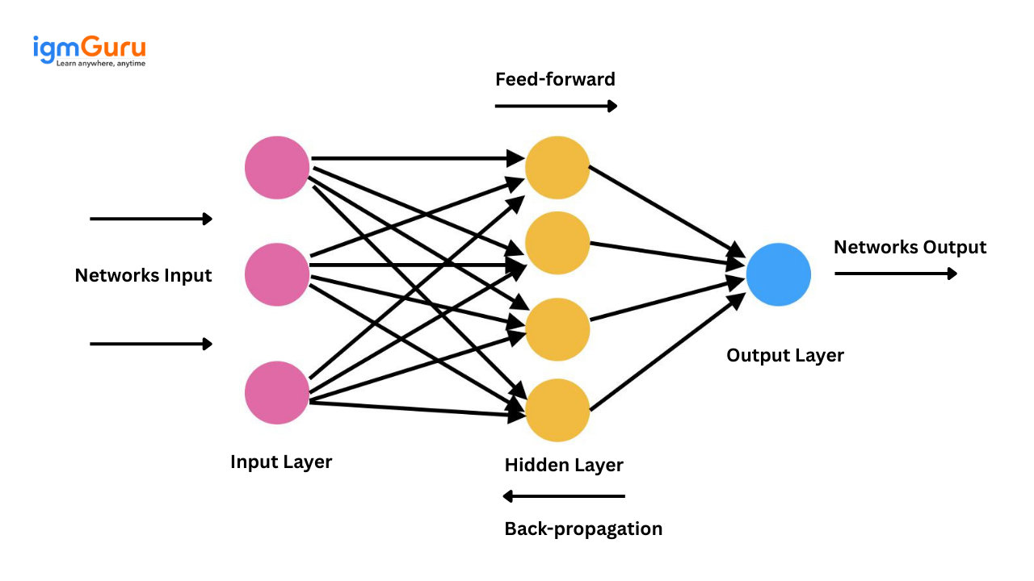
Importance and Applications of ANNs:
ANNs are important because they can model complex, non-linear relationships and improve decision-making in various fields. They are widely used in:
- Image Recognition: Detecting objects or faces in photos.
- Healthcare: Diagnosing diseases like cancer or predicting patient outcomes.
- Finance: Predicting stock prices or detecting fraud.
- Natural Language Processing (NLP): Chatbots, language translation, and speech recognition.
- Autonomous Systems: Self-driving cars and robotics.
- . Speech Recognition: Converting spoken language into text in voice assistants.
- Recommendation Systems: Suggesting products, movies, or music based on user behavior.
.
Basic Structure of an ANN:
Artificial Neural Networks (ANNs) are made up of neurons connected together, similar to how the human brain works. The main components of an ANN are:
Neurons and Connections:
- A neuron is the basic unit of an ANN. It receives input, processes it, and sends output to other neurons.
- Neurons are connected through weights, which determine the importance of each input.
- Each neuron also has a bias, which helps adjust the output along with the weights.
Input, Hidden, and Output Layers:
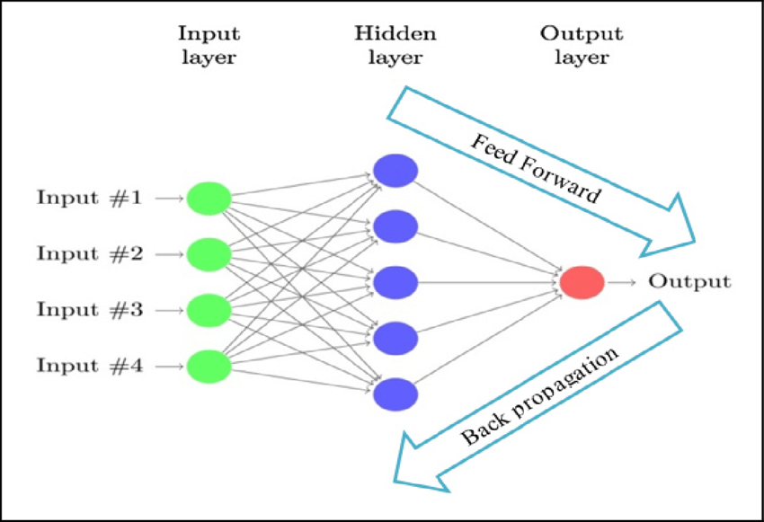g
- Input Layer: This is the first layer of the network. It takes data from the outside world, such as numbers, images, or text. Each input is sent to neurons in the next layer.
- Hidden Layers: These layers are between input and output. They process the information from the input layer and extract patterns. There can be one or more hidden layers.
- Output Layer: This layer produces the final result, such as a prediction, classification, or decision.
Activation Functions:
- Activation functions decide whether a neuron should be activated or not, based on the input it receives.
- Common activation functions include:
  - Sigmoid: Produces output between 0 and 1.
  - ReLU (Rectified Linear Unit): Outputs the input directly if positive, otherwise 0.
  - Tanh: Outputs values between -1 and 1.
  - Softmax: Used in classification to convert outputs into probabilities.
Feedforward Neural Network:
Feedforward Flow:
A Feedforward Neural Network is the simplest type of ANN where information moves in one direction only — from the input layer, through hidden layers, to the output layer. There are no loops or cycles.
- Each neuron receives input values, multiplies them by the corresponding weights, adds a bias, and passes the result through an activation function.
- The output of one layer becomes the input for the next layer.
- The process continues layer by layer until the final output is produced in the output layer.
- This flow of data is called forward propagation.
Diagram of a Simple ANN:
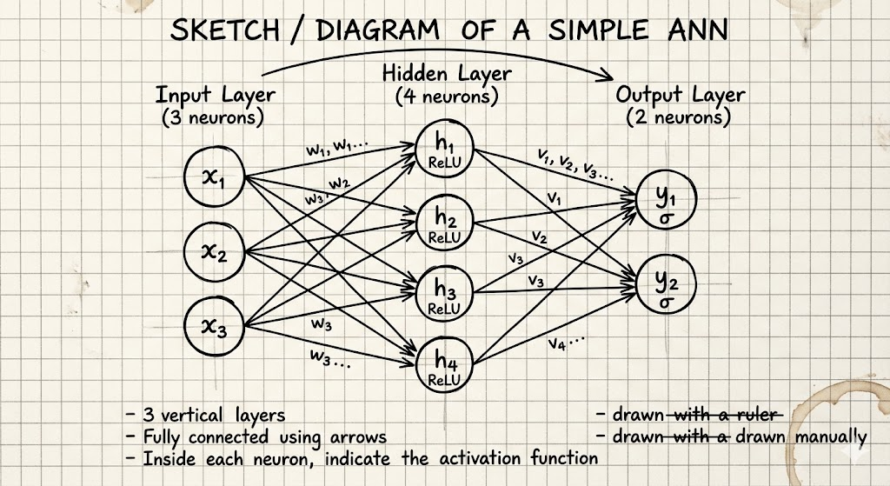
Label:
  - Input Layer: x₁, x₂, x₃
  - Hidden Layer: h₁, h₂, h₃, h₄
  - Output Layer: y₁, y₂
  - Arrows can be labeled as weights (w₁, w₂, …)
  - Inside each neuron, indicate the activation function, e.g., Sigmoid or ReLU.
- Inputs are fed into the input layer neurons.
- Data moves forward through hidden layers, being multiplied by weights, added to biases, and processed by activation functions.
- The final output layer produces predictions or classifications.
- There is no backward flow in feedforward networks; that happens during learning
Activation Functions:
In an Artificial Neural Network, activation functions determine how the input to a neuron is transformed into an output. They help the network learn complex patterns and decide whether a neuron should be “activated” (send a strong signal) or not. Without activation functions, the network would behave like a simple linear system and could not solve non-linear problems.
Common Activation Functions:
- Sigmoid:
  - Formula: σ(x) = 1 / (1 + e^(-x))
  - Output ranges between 0 and 1.
  - Useful for probabilities and binary classification.
  - Example: Input x = 0 → Output = 0.5
- ReLU (Rectified Linear Unit):
  - Formula: f(x) = max(0, x)
  - Output is 0 if input is negative; output equals input if positive.
  - Very popular in hidden layers because it speeds up learning.
  - Example: Input x = -2 → Output = 0, Input x = 3 → Output = 3
- Tanh (Hyperbolic Tangent):
  - Formula: tanh(x) = (e^x - e^-x) / (e^x + e^-x)
  - Output ranges between -1 and 1.
  - Useful when you want outputs centered around zero.
  - Example: Input x = 0 → Output = 0
- Softmax:
  - Converts outputs into probabilities that sum to 1.
  - Formula: softmax(xᵢ) = e^(xᵢ) / Σ e^(xⱼ) for all j
  - Commonly used in the output layer for multi-class classification.
  - Example: Outputs [2, 1, 0] → Probabilities [0.665, 0.244, 0.091]
How Activations Influence Neuron Output:
- They control the strength of the signal passed to the next layer.
- Non-linear activations like Sigmoid, ReLU, and Tanh allow the network to learn complex patterns.
- Softmax converts multiple outputs into probabilities, making it easy to interpret the network’s prediction.
- Activation functions determine if a neuron should “fire” and pass its signal forward.
- Sigmoid outputs values between 0 and 1, useful for binary predictions.
- ReLU speeds up learning by keeping positive signals and discarding negative ones.
- Tanh outputs between -1 and 1, helpful for zero-centered data.
- Softmax is used for multi-class classification to give probability scores.
- Choosing the right activation function is important for the network’s performance.
Forward Propagation:
Forward propagation is the process by which input data moves through the network to produce an output. It is the first step in how a neural network works before learning and adjusting its weights.
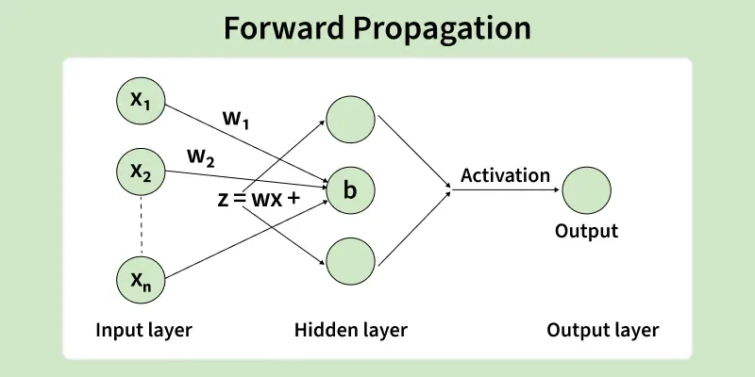
How Input Passes Through the Network:
- Inputs are provided to the input layer neurons.
- Each input is multiplied by a weight, which determines the strength of that connection.
- A bias is added to the weighted sum to adjust the output.
- The result is passed through an activation function, which determines the neuron’s output.
- The outputs of one layer become the inputs for the next layer.
- This process continues until the output layer produces the final result.
Calculation of Outputs:
- For a single neuron, the output can be calculated as:
Output = Activation Function (Σ(Input × Weight) + Bias)
- Example:
  - Inputs: x₁ = 1, x₂ = 2
  - Weights: w₁ = 0.5, w₂ = 0.3
  - Bias: b = 0.1
  - Weighted sum = (1×0.5) + (2×0.3) + 0.1 = 1.2
  - If activation function is Sigmoid: Output = 1 / (1 + e^-1.2) ≈ 0.77
Role of Weights and Biases:
- Weights (w): Control how much influence each input has on the neuron’s output.
- Bias (b): Allows the activation function to be shifted left or right, giving the network more flexibility.
- Together, weights and biases determine the network’s behavior and are adjusted during learning to improve accuracy.
Backpropagation
Backpropagation is the process by which an Artificial Neural Network learns from errors and improves its performance. After forward propagation produces an output, backpropagation helps adjust the weights and biases to reduce the difference between predicted and actual outputs.
Concept of Error Calculation:
- The error is the difference between the predicted output (from forward propagation) and the actual output (target).
- Example: If the target output is 1 and the network predicts 0.77, the error = 1 - 0.77 = 0.23
- The goal is to minimize this error across all training examples.
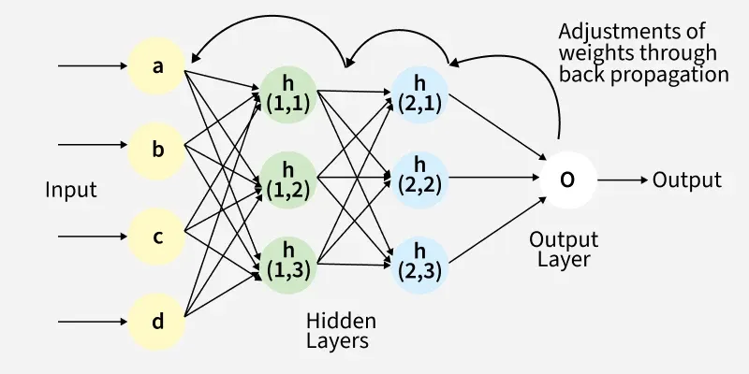
Gradient Descent and Weight Adjustment:
- Gradient Descent is an optimization method used to reduce the error.
- It calculates the gradient (slope) of the error function with respect to each weight and bias.
- Weights are updated in the opposite direction of the gradient to decrease the error:
New Weight = Old Weight - Learning Rate × Gradient
- The learning rate determines how big a step is taken in each update.
Working of Backpropagation:
- Perform forward propagation to get the network’s output.
- Calculate the error at the output layer.
- Compute the gradient of the error with respect to each weight and bias.
- Adjust the weights and biases using gradient descent.
- Propagate the error backward to previous layers and repeat the weight adjustment.
- Continue this process for many iterations (epochs) until the network converges to minimal error.
Example:
- Suppose a neuron has weight w = 0.5, bias b = 0.1, input x = 1, and learning rate = 0.1.
- Error gradient = 0.2
- Weight update: w_new = 0.5 - 0.1 × 0.2 = 0.48
- Bias update: b_new = 0.1 - 0.1 × 0.2 = 0.08

Learning Process of ANN:
The learning process is how an Artificial Neural Network (ANN) improves its performance over time by adjusting weights and biases based on training data.
Training the Network with Examples:
- ANNs learn by being trained on a set of input-output examples called the training dataset.
- Each input is fed through the network (forward propagation) to produce an output.
- The error is calculated by comparing the predicted output with the actual output.
- Backpropagation is used to adjust weights and biases to reduce the error.
- This process is repeated for all training examples multiple times, called epochs, so the network gradually learns the patterns in the data.
Convergence and Stopping Criteria:
- Convergence happens when the network reaches minimal error and the weights no longer change significantly.
- Stopping criteria can include:
  - The error falls below a predefined threshold.
  - The network completes a fixed number of epochs.
  - No significant improvement in validation accuracy over several epochs.
Avoiding Overfitting:
- Overfitting occurs when the network memorizes the training data instead of learning general patterns.
- To avoid overfitting:
  - Use a validation dataset to monitor performance on unseen data.
  - Apply regularization techniques like L1 or L2 penalties.
  - Use dropout, which randomly disables neurons during training.
  - Ensure sufficient and diverse training data.
Applications of ANN:
Artificial Neural Networks are widely used in many fields because of their ability to learn from data and make intelligent decisions. Some important applications with real-life examples are:
1. Image Recognition:
- ANNs can identify objects, faces, or handwritten digits in images.
- Example: Social media platforms like Facebook automatically tag friends in uploaded photos using ANNs.
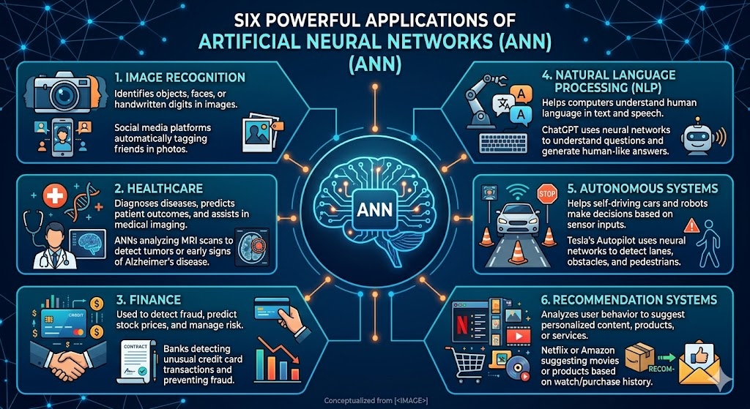
2. Healthcare:
- ANNs help diagnose diseases, predict patient outcomes, and assist in medical imaging.
- Example: ANNs analyze MRI scans to detect tumors or early signs of Alzheimer’s disease.
3. Finance:
- ANNs are used to detect fraud, predict stock prices, and manage risk.
- Example: Banks like HSBC use ANNs to detect unusual credit card transactions and prevent fraud.
4. Natural Language Processing (NLP):
- ANNs help computers understand human language in text and speech.
- Example: ChatGPT uses neural networks to understand questions and generate human-like answers.
5. Autonomous Systems:
- ANNs help self-driving cars and robots make decisions based on sensor inputs.
- Example: Tesla’s Autopilot uses neural networks to detect lanes, obstacles, and pedestrians.

Conclusion:
Artificial Neural Networks (ANNs) are a powerful technology in artificial intelligence that allow machines to learn from data, recognize patterns, and make intelligent decisions.
Key Points:
- ANNs are inspired by the human brain and consist of neurons, weights, biases, and activation functions.
- Feedforward networks allow information to flow from input to output layers, while backpropagation helps the network learn by correcting errors.
- Activation functions like Sigmoid, ReLU, Tanh, and Softmax control how signals pass through neurons.
- Forward propagation calculates outputs, and backpropagation adjusts weights and biases to reduce errors.
- The learning process involves training on examples, monitoring convergence, and avoiding overfitting for better generalization.
- ANNs have widespread applications in image recognition, healthcare, finance, NLP, autonomous systems, and recommendation engines.
Importance of ANN in Modern AI:
- ANNs are the foundation of deep learning and modern AI systems.
- They enable machines to solve complex, non-linear problems that traditional programming cannot handle.
- ANNs are used in critical areas such as medical diagnosis, autonomous vehicles, fraud detection, and virtual assistants, making them essential in today’s technology-driven world.
In conclusion, understanding ANNs, their structure, learning process, and applications is crucial for anyone working in artificial intelligence and machine learning.

Individual Task-5
“Create an ANN Flowchart: Manually sketch a feedforward neural network, label layers, activations, explain how backpropagation adjusts weights.”
Introduction:
Overview of Chatbots and Sales Conversation:
Chatbots are computer programs powered by artificial intelligence (AI) that simulate human conversation. They are designed to interact with users in a natural, conversational way, either through text or voice. In the context of sales, chatbots act as virtual sales assistants, guiding customers to products or services, answering their questions, providing recommendations, and even helping complete purchases.
Sales chatbots are widely used in e-commerce, banking, travel, and service industries, where they handle repetitive queries and assist multiple users simultaneously. They save time for both customers and businesses while improving efficiency.
Importance of Analyzing Chatbot Interactions:
Analyzing chatbot conversations is important because not all interactions go smoothly. A chatbot may:
- Misinterpret customer intent.
- Give vague or irrelevant responses.
- Fail to guide the customer to a purchase or solution.
- 
By analyzing conversations, we can:
- Evaluate how well the chatbot understands user requests.
- Identify areas where it needs improvement, such as understanding complex queries or using better language.
- Assess the chatbot’s effectiveness in closing a deal or assisting a customer in making a decision.
- Improve the overall user experience, leading to higher customer satisfaction and increased sales.
Objective of the Task:
The main purpose of this task is to interact with a sales chatbot and evaluate its performance in a real-world conversation. By doing this, we can understand both how well the chatbot interprets user requests and how effectively it can guide a conversation toward a successful outcome.

Understanding Chatbot Intent Recognition:
- Intent recognition is the chatbot’s ability to understand what the user wants.
- The chatbot must correctly identify whether the user is:
  - Asking for product information
  - Requesting support or troubleshooting
  - Looking to make a purchase
- Evaluating intent recognition helps assess the chatbot’s intelligence and how well it handles user queries.
Evaluating Conversation Effectiveness in Closing a Deal:
- A chatbot’s success is not just understanding intent but also guiding the conversation to a desired outcome, such as a purchase or service request.
- Key points to evaluate:
  - How clearly the chatbot provides information.
  - Whether it suggests relevant products or services.
  - How efficiently it leads the user toward completing a transaction.
- An effective chatbot ensures smooth interaction and higher chances of a successful sale.
- The task aims to study chatbot performance in a sales conversation.
- Intent recognition shows how accurately the chatbot understands user queries.
- Evaluating deal closure measures how effectively the chatbot guides the user toward action.
- Both intent understanding and deal guidance are essential for a successful sales chatbot.
- The analysis will help identify strengths, weaknesses, and areas for improvement.
Chatbot Interaction Setup:

To analyze a chatbot sales conversation, it is important to first set up the environment and tools for interaction. This ensures the process is smooth and the data collected is useful for evaluation.
Tools/Platforms Used:
- Website or Mobile App: A platform with a sales or customer-service chatbot, such as Amazon, Flipkart, or a banking app.
- Recording Tool: Optional tools like screen recorder or note-taking app to document the conversation for later analysis.
- Device: A smartphone, tablet, or computer to interact with the chatbot.
Steps to Initiate a Sales Conversation:
- Open the chosen website or app with a chatbot feature.
- Locate the chatbot window, usually appearing as a chat icon on the bottom corner.
- Start the conversation with a greeting or query, e.g., “Hi, I want to buy a laptop.”
- Respond naturally to the chatbot’s prompts as a customer would.
- Explore different questions or scenarios to test its understanding and ability to guide you toward a deal.
- Document the conversation carefully, noting correct responses, errors, or misunderstandings.
Conversation Analysis
Once the chatbot conversation has been recorded, it is important to analyze the interaction to evaluate its effectiveness. This helps identify how well the chatbot understands the user and how it handles queries.
Recording the Conversation:
- Use a screen recorder or note-taking method to capture the full conversation.
- Record the user queries, the chatbot responses, and the flow of the conversation.
- This documentation allows for detailed evaluation later.
Evaluating Chatbot Understanding of Customer Intent:
- Review each response from the chatbot to see if it correctly interprets what the user wants.
- Check if the chatbot:
  - Provides accurate information related to the user query.
  - Asks relevant follow-up questions when needed.
  - Responds clearly and appropriately to varied inputs.
- Proper intent recognition indicates that the chatbot can understand different types of customer requests.
Identifying Misrecognitions or Misunderstandings:
- Note any responses where the chatbot:
  - Misinterprets the question or intent.
  - Gives irrelevant or repeated answers.
  - Fails to guide the user toward the desired outcome.
Deal Closing Evaluation:
Evaluating how a chatbot closes a deal is crucial to measure its effectiveness in sales conversations. A successful chatbot not only understands the user but also guides them toward completing a transaction or desired action.

How the Chatbot Guides the Conversation Toward a Deal:
- The chatbot provides clear and relevant information about products or services.
- It asks follow-up questions to understand customer preferences.
- Offers recommendations or alternatives based on the user’s needs.
- Suggests next steps, such as adding a product to the cart, booking a service, or confirming an order.
- Maintains a smooth flow to prevent customer confusion and improve chances of conversion.
Measuring Success:
- Completing a Purchase: The chatbot helps the user finalize the transaction efficiently.
- Providing Information: The chatbot clearly answers questions about product features, price, or availability.
- Upselling or Cross-Selling: The chatbot suggests additional products or upgrades, increasing potential sales.
- Customer Satisfaction: User feels guided and supported throughout the conversation.

Common Errors and Limitations:
Even the most advanced chatbots have limitations. Understanding these helps identify areas for improvement and make the chatbot more effective in sales conversations.
Misinterpreted Queries:
- Chatbots sometimes fail to understand user intent, especially if the query is complex or phrased unusually.
- Example: The user asks, “Do you have laptops under 50,000?” and the chatbot responds with unrelated accessories instead of products.
- Misinterpretations reduce the chatbot’s ability to guide the user effectively.
Repetitive Responses or Failed Follow-Ups:
- Some chatbots repeat the same answers instead of adapting to the user’s new queries.
- They may fail to follow up when clarification is needed.
- Example: After a user asks for product comparison, the chatbot repeats product details without answering the question.
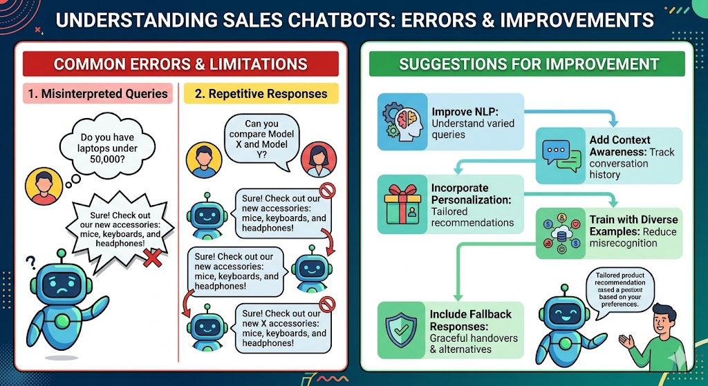

Suggestions for Improvement:
- Improve Natural Language Processing (NLP) to understand varied query formats.
- Incorporate context awareness to track conversation history and user preferences.
- Add personalization features for tailored recommendations.
- Train the chatbot with more diverse examples to reduce misrecognition.
- Include fallback responses to handle unexpected queries gracefully.
Conclusion:
Analyzing a chatbot’s sales conversation is essential to understand how well it interprets customer intent and how effectively it can guide users toward a deal.
Summary of Findings:
- Chatbots are useful for automating sales and customer-service interactions.
- They can answer queries, provide information, and guide users toward purchases.
- Analysis of the conversation helps identify misinterpretations, repetitive responses, and failed follow-ups.
- Effective chatbots maintain a smooth conversation flow, ask relevant follow-up questions, and provide recommendations.
- Suggestions for improvement include better NLP, context awareness, personalization, and diverse training data.
Importance of Intent Accuracy for Customer Satisfaction and Sales:
- Accurate intent recognition ensures the chatbot understands customer needs and provides relevant responses.
- High intent accuracy improves user experience, increases trust, and reduces frustration.
- It also increases the likelihood of successful deal closure, improving sales and business performance.
- Regular evaluation and updates are essential to maintain chatbot efficiency and effectiveness.
- Chatbots are valuable tools in sales and customer service.
- Evaluating conversations helps improve performance and identify errors.
- Accurate intent recognition is critical for customer satisfaction.
- Efficient deal guidance increases sales success.
- Continuous improvement ensures the chatbot remains effective and user-friendly.

